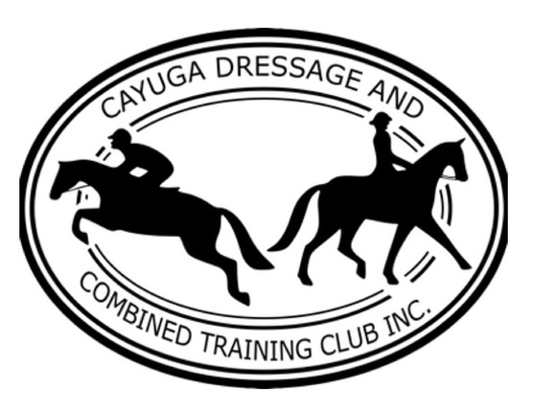
Cayuga Dressage and Combined Training
(An Affiliation Organization of USAWE) Presents
Experiencing Working Equitation Obstacles, Part Two:
A Practical Application of the Principles of Working Equitation

May 3, 2026
Cazabu Farm, 3675 Erieville Road, Erieville, NY

Name:
Address:
Phone: Email:
Name and Age of Horse:
Would you consider this horse well behaved with other horses in an arena?
(There will be up to eight horses in the large arena at the same time)
Age of Participant (if under 21):
Name of Parent or Guardian:
Ride Session Preference:
Morning (8:30-1) Afternoon (1-5:30) No Preference
Are you trailering with another participant and if so, who?
Event Cost:
_________ Participant > Member (CDCT, CNYDCTA, WNYDA) Rate: $35/session
_________ Participant > Non-Member Rate: $50/session
_________ Auditor > Member (CDCT, CNYDCTA, WNYDA) Rate: Free!
_________ Auditor > Non-Member Rate: $15/day
HOLD HARMLESS AGREEMENT
My signature below indicates that I hold Cayuga Dressage and Combined Training, Inc., its Officers and Board and their heirs, Rick and Leigh Garber, owners of Cazabu Farm in Erieville, NY owners and their heirs harmless for any harm, including death, that may occur while at this event. I also indicate that I and any members of my party agree to abide by the guidance and directives of clinic organizers and the posted rules of this facility while on these premises, whether as an auditor or a participant.
Rider/Auditor Name (please print):
Rider/Auditor Signature:
Parent/Guardian Name (if under 21; please print):
Parent/Guardian Signature (if under 21):
Horse Owner Name (please print):
Horse Owner Signature:

If mailing your entry, please submit with a check made out to CDCT, Inc. to: Jane Marie Law, 16 Muriel Street, Ithaca, NY 14850. If the weather is under 25° or if the roads are bad in Erieville on the day of the event, we will reschedule and your check will not be cashed. Include a copy of negative Coggins and proof of rabies/flu/rhino vaccines with your registration. Electronic entries can be emailed to jml16@cornell.edu. We accept Paypal to dressageithaca@gmail.com and Venmo @dressageithaca.

